Post session exercise -1

1. What is the major problem being solved?

**issues** of public security, all leading to ... considered, and action taken to **solve** the **issue** in a mutually satisfactory manner.

1. What are the other problem being solved?

Digital Health and Wellbeing **Solution**

1. Who are the users of the system?

* Doctor
* Patient
* Web developer / web designer
* Quality assurance engineer
* Administrative user

1. What benefits the each user gets?

* Doctor - doctor can treat the patients any time in any location
* Patient - he/she can get the benefit for the disease without stepping out also can order the medicine
* Web developer / web designer - they can develop the software / website by improving new technique also they get the benefit too
* Quality assurance engineer – can understand the customer wants and give the developer the idea to maintain it
* Administrative user - can get the full knowledge of database and understand for which disease customers are usually coming for..

1. What are the other alternative similar system available and do a comparison?

doc.lk

lankahospitals.com

epid.gov.lk

nawaloka.com

lankadoctor.com

For more similar website : <https://www.sitelike.org/similar/echannelling.com/>

Zocdoc : <https://www.zocdoc.com/>

Echanneling : <https://www.echannelling.com/Echannelling/index?view=hidden&deviceCode=na>

Zocdoc vs Echanneling

In zocdoc there is a full calendar showing also the image of the doctor and can review too but in echanneling they are showing only the name and dates available but not showing the image of the doctor

1. Understand the process of channeling a doctor and briefly describe in words and in graphical way?

First input all the data (doctor’s name/ specialization/ date/ hospital) of the doctor

And then check the hospital which doctor is available and book it

Then confirm the date and time

Input all your details (name/ telephone number/ NIC/ email address.. ) while accepting the terms and condition and proceed

And the Payment gateway steps

Your done!

1. Describe the each user interface used in the process (work flow) of channeling the doctor?

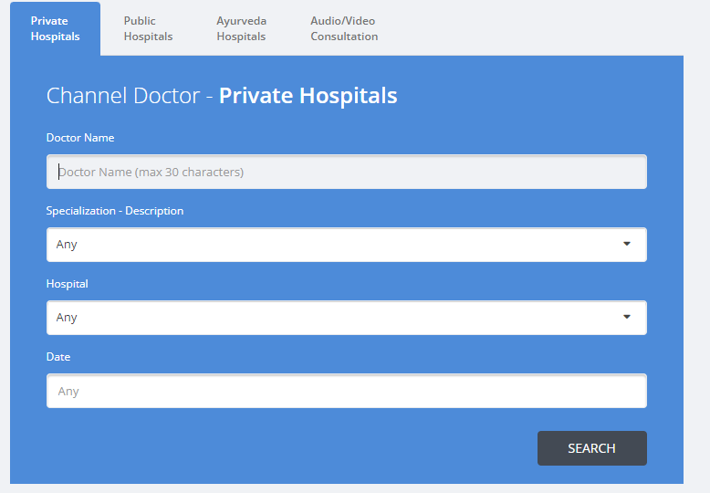

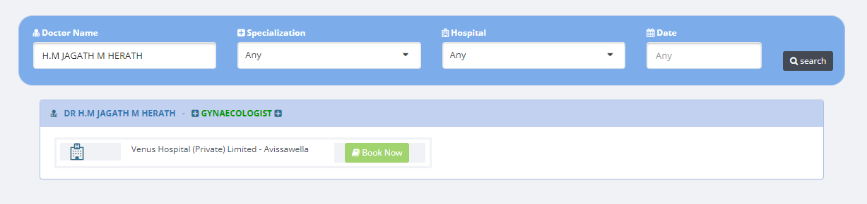

Doctor’s availability of the hospital

Input doctor’s details

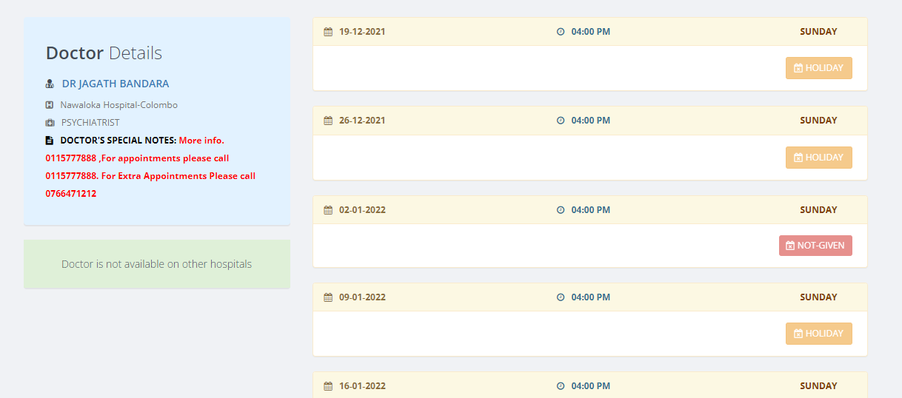

Doctor’s availability of date and time

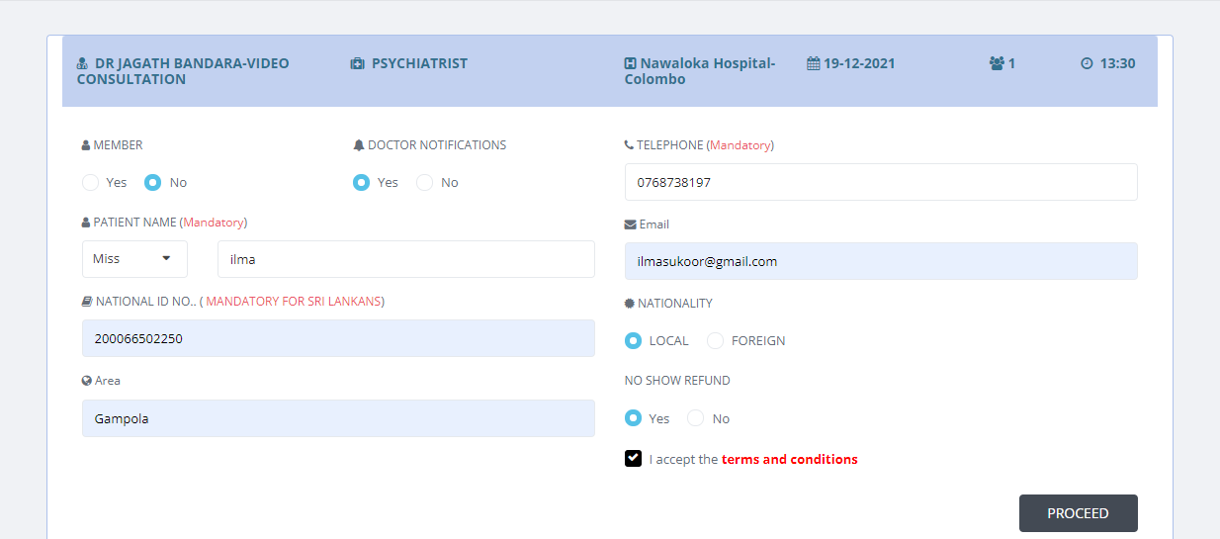

Fill the patient details

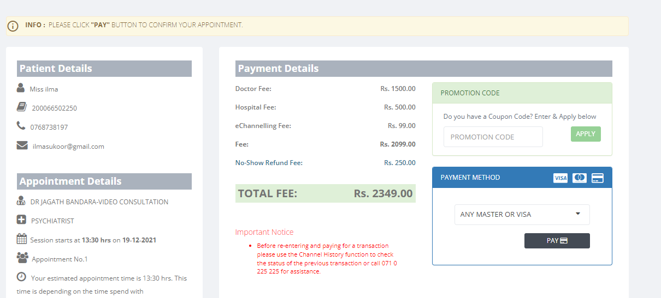z

Opening to payment gateway

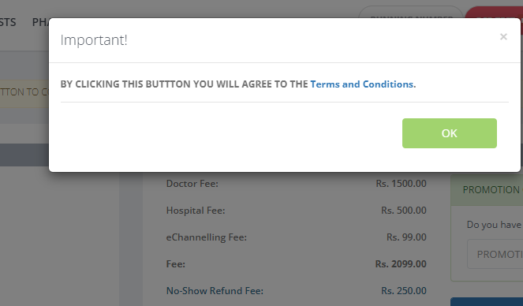

Terms and condition

1. What is the type of software solution?

Web

1. What should be the data stored in the database?

Customer’s details and their performance

Doctor’s availability and their function and can find how many hours they are spending in the website

10. Technical diagram

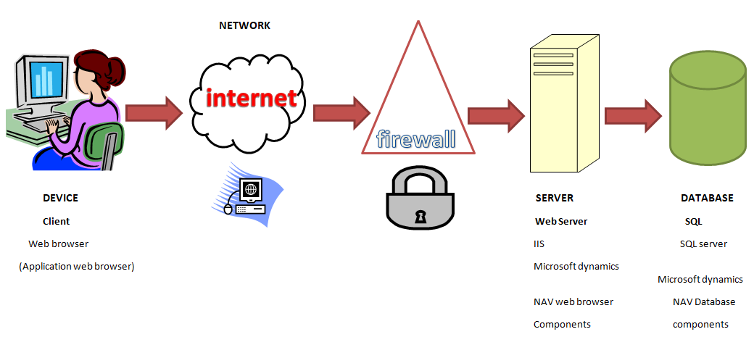

11. Administrative user

Yes

Doctor’s availability and their function

Finding how many hours doctors spending in the website

Customer’s performance

12. Finding doctor’s experience

13. Can show in their profile

THANK YOU

ILMA 4597